**WHAT IS GIT?**

GIT IS A DISTRIBUTED VERSION CONTROL SYSTEM.

* When working on a project we can easily distribute the work.
* The main project is kept on the server and each user has it copy.
* Users can work offline

**Repository :**

Repository is a local copy of the project which contains the history of the project.

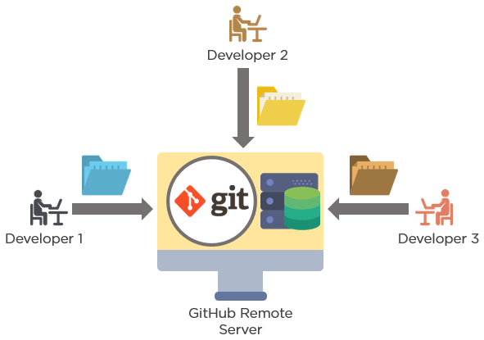

**BRANCHING IN GIT**

A **branch in Git** is simply a lightweight movable pointer to one of these commits

The default **branch** name in **Git** is master.

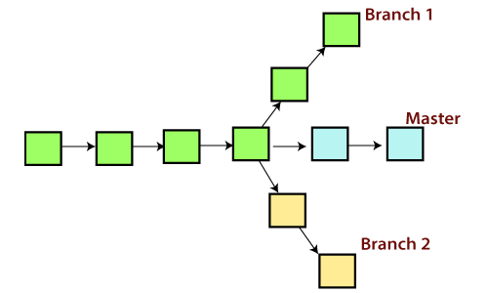

**States and sections in GIT :**

GIT has three main states that your files can reside in:

* *Committed*
* *Modified*
* *Staged*

**Committed**

This state indicates that the file is safely stored in the local database.

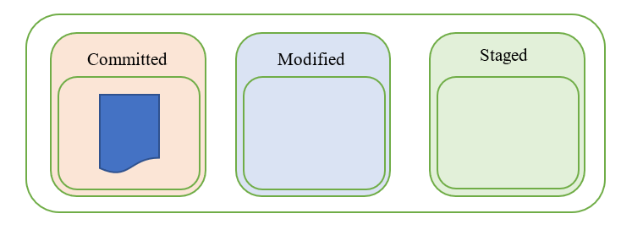

### ****Modified****

When any change to the file occurs, the state of the file changes from committed to modified. This means that the document has changed since its last committed version which is saved to our local database. We can see this state as 'we're currently working on this file, there will still be more changes'.

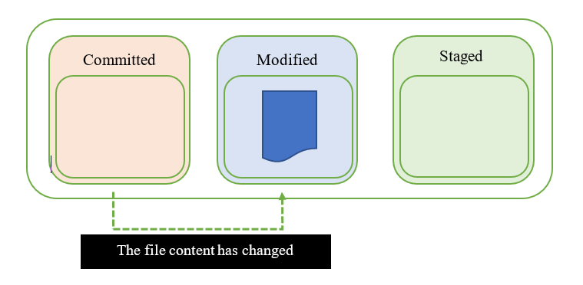

### ****Staged****

When we're finished with all the modifications to our file, it moves to the staged state. The file is now ready to be added to the local git database, you have marked it to go into your next commit snapshot.

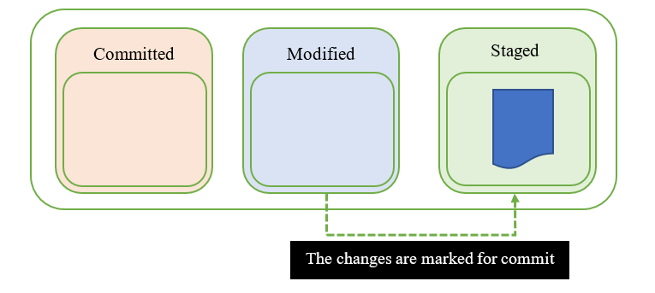

GIT COMMANDS

**UPLOADING FILE ON GIT REPOSITORY**

cd "file path"

Git init

Git remote add origin “Git repository Link”

Git remote -v

Git add .

Git commit –m “comment”

Git push origin master

Creating a local copy for git repository

Cd “file path”

Git config --global user.name “your user name”

Git config --global user.email “Your email address”

Git clone “Repository Link”

Git branch list

$ cd "Path"

$ git init

$ git remote add origin (Repository Link)

$ git remote -v

$ git add .

$ git commit -m "master branch"

$ git push origin master -ff

$ cd "path”

$ git config --global user.name "simon123-lab"

$ git config --global user.email “[simon@aptechgdn.net](mailto:simon@aptechgdn.net)”

$ git clone Repository

$ git branch

$ git checkout -b newbranch

$ git checkout master

$ git checkout newbranch

$ touch (filename)

$ git status

$ git add .

$ git status

$ git commit -m "File added to newbranch"

$ git push --set-upstream origin newbranch